**Name: Arma Sajjad**

**Roll no: l1f22bsse0343**

**G Lab: 4**

**- _________________________________________Q=1**

select count(*)

from track as t

where exists (

select *

from genre as g

where t.GenreId=g.GenreId

AND g.name="Pop"

);

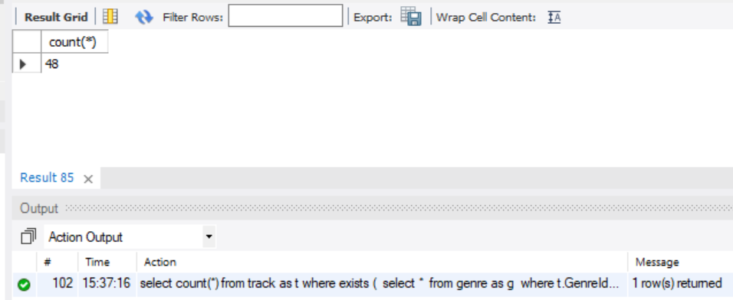

**-- _________________________________________Q=2**

select FirstName, LastName

from customer as c

where exists (

select *

from invoice as i

where c.CustomerId=i.CustomerId

and i.invoiceDate=(

select max(ii.invoiceDate)

from invoice as ii

)

);

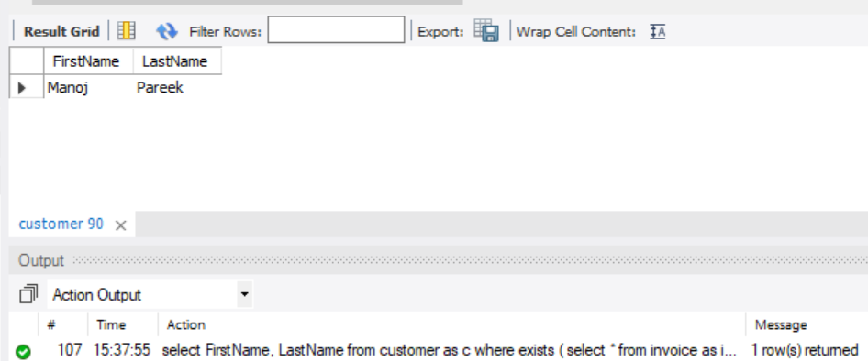

**-- _________________________________________Q=3**

select *

from Employee

order by HireDate asc

limit 1;

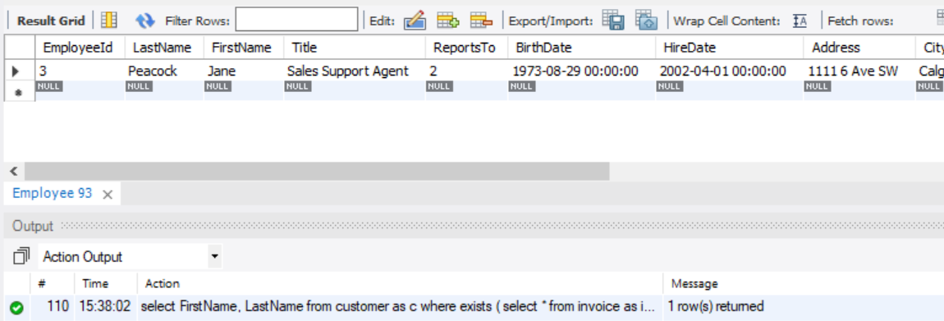

**-- _________________________________________Q=4**

select a.ArtistId, a.Name, COUNT(ab.AlbumId)

from Artist as a

left join Album ab

on a.ArtistId = ab.ArtistId

group by a.ArtistId, a.Name

order by a.ArtistId;

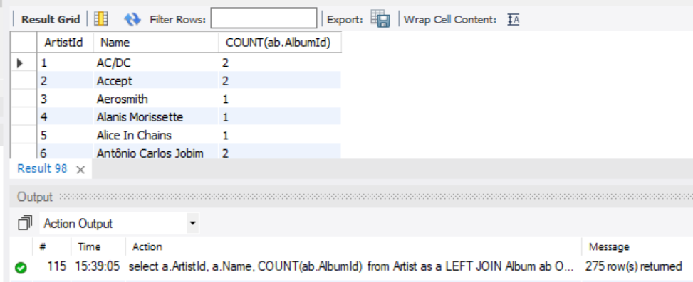

**-- _________________________________________Q=5**

select SUM(i.Quantity)

from InvoiceLine as i

where exists (

select 1

from Invoice as v

where v.InvoiceId =i.InvoiceId

and v.BillingCity = 'Oslo'

);

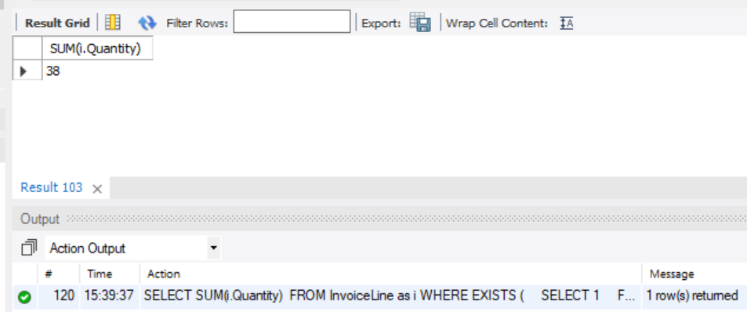

**-- _________________________________________Q=6**

select *

from Track

where Milliseconds <(

select AVG(Milliseconds)

from Track

)

LIMIT 1000;

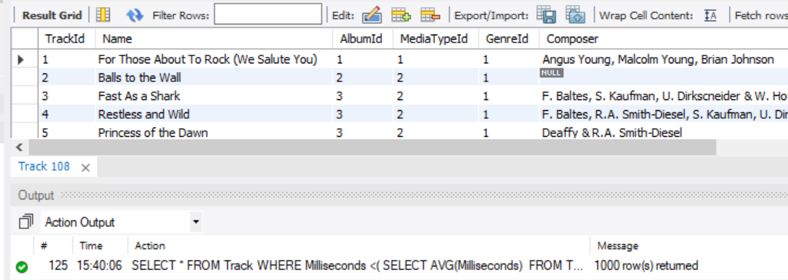

**-- _________________________________________Q=7**

select COUNT(*)

from track as t

join mediatype as m

on t.MediaTypeId = m.MediaTypeId

where m.Name = 'MPEG';

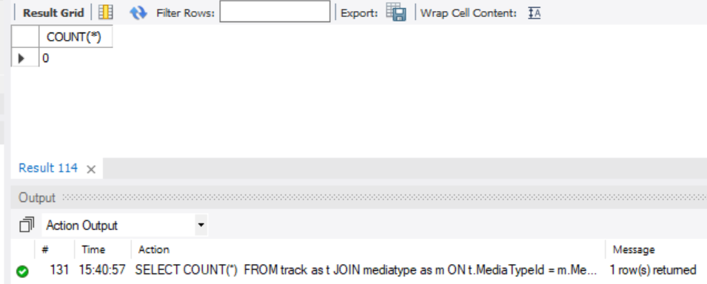

**-- _________________________________________Q=8**

select COUNT(*)

from Employee as emp

where not exists (

select *

from Customer as cust

join Invoice as inv on cust.CustomerId = inv.CustomerId

where cust.SupportRepId = emp.EmployeeId

);

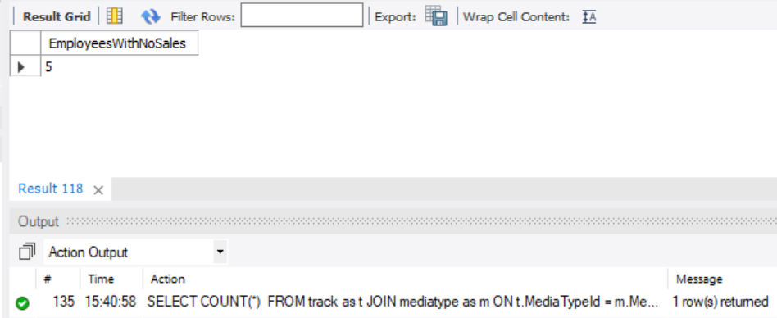

**-- _________________________________________Q=9**

select t.Milliseconds, t.TrackId, t.AlbumId, a.Title , ar.Name

from Track as t

join Album as a

on t.AlbumId = a.AlbumId

join Artist as ar

on a.ArtistId = ar.ArtistId

where

t.Milliseconds > (

select avg(Milliseconds)

from Track

);

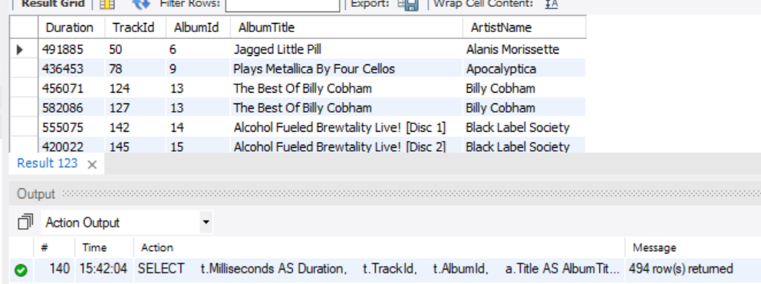

**-- _________________________________________Q=10**

select SUM(i.Total)

from Invoice as i

where exists (

select *

from InvoiceLine as il

join Track as t

on il.TrackId = t.TrackId

where il.InvoiceId = i.InvoiceId

and t.Name = 'Evil Walks'

);

